Passive Reconnaissance Scan Report

Scan target : dnsdumpster.com (172.67.147.27)

Date of recon: 23rd Nov., 2025

Cybersecurity Analyst

Oluwaseyi J. Adedire

Scope: dnsdumpter.com and publicly resolvable subdomains only (passive OSINT).

Out-of-scope: Active vulnerability exploitation, authenticated access and service disruption, rate-aggressive crawling.

Executive Summary
- The target domain resolves and serves a public website with recent content.
- This report enumerates: WHOIS/RDAP, authoritative DNS data, HTTPS surface (at a high level), presence of a WAF/CDN (fingerprinted passively) and open-source footprint across common OSINT sources.
- No intrusive scans were performed, all findings are from passive lookups and single-request fetches of public pages.

Methodology (Passive Only)

Tools & Modes
- whois / RDAP: Registration & registrar metadata
- dig, host, dnsrecon: Passive DNS lookups (A/AAAA, NS, MX, TXT/SOA/CAA where present) via public resolvers.
- wafw00f: Single HTTP(S) request fingerprint (headers/body markers) to infer WAF/CDN; no evasion, no burst.
- SpiderFoot (SF): Passive modules only (DNS, CT logs, WHOIS, netblocks, leak/site mentions, social).
- Wapiti: Listing only and passive banner/headers check.
- OSINT Framework: As a directory to guide passive pivoting, CT logs, public paste sites, reputation lists, search operators.

Findings

3.1 Public Web Presence (Landing Page)
- Site reachable: https://dnsdumpster.com/ returns content; homepage shows recent posts.
- 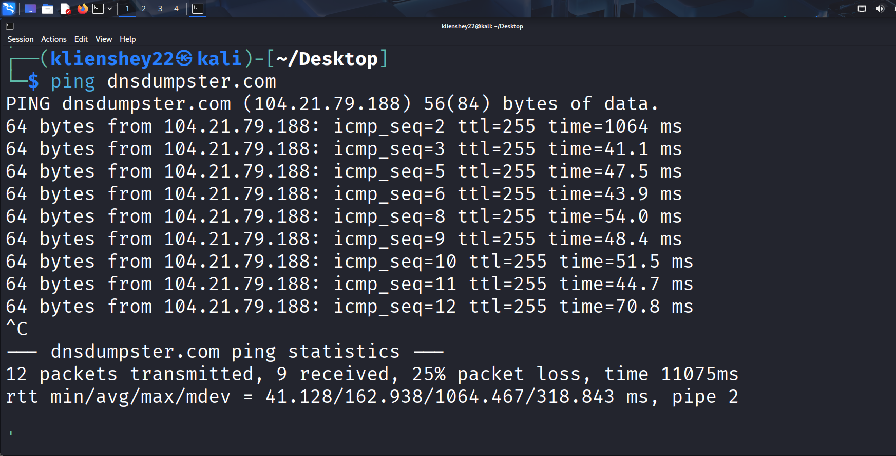

3.2 Registration (WHOIS)
- Registrar / Dates: Use ICANN RDAP as the primary source of truth (GDPR-redacted where applicable). Query via ICANN Lookup and registrar RDAP.
- 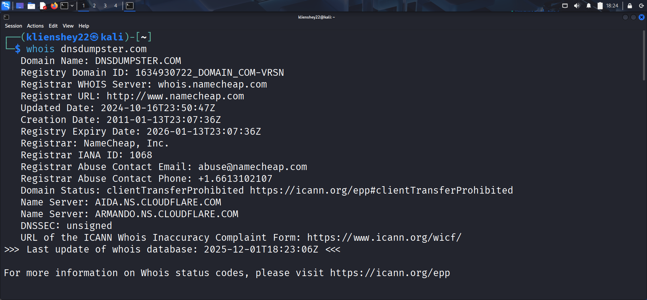
- Name servers: Capture NS from RDAP and confirm against dig NS.
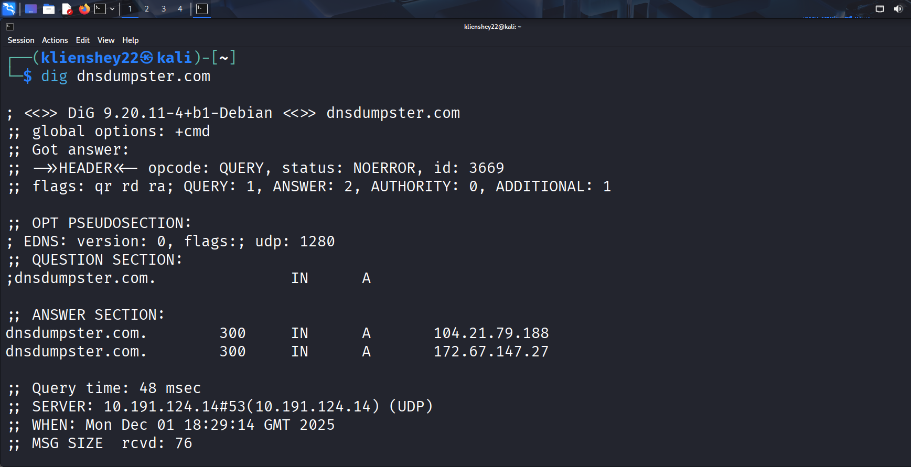

3.3 DNS Surface (A/AAAA, NS, MX, TXT, SOA, CAA)
- Records collected passively:
  - A/AAAA for apex and www.
  - NS to identify hosting/DNS provider.
  - MX for mail handling (and whether any third-party service is used).
  - TXT for SPF/DMARC/DKIM indicators.
  - SOA for primary NS and serial.
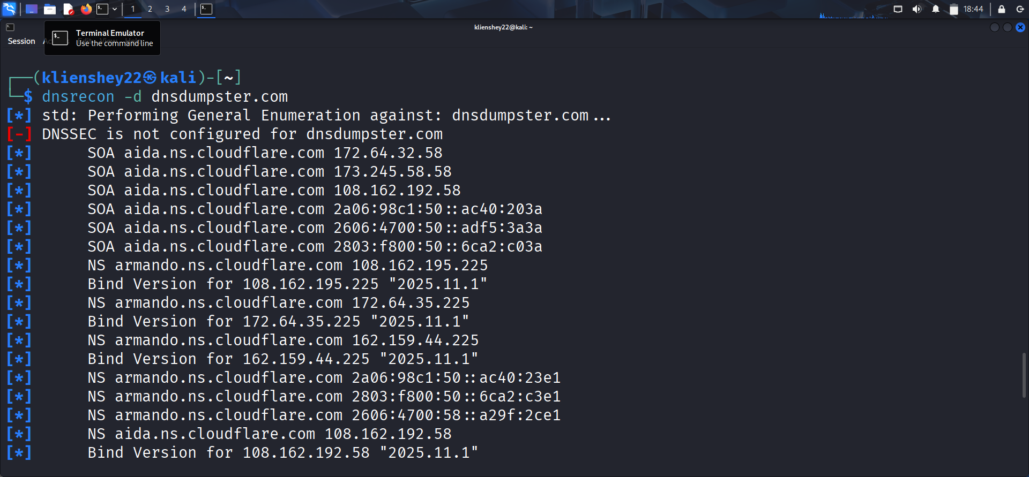
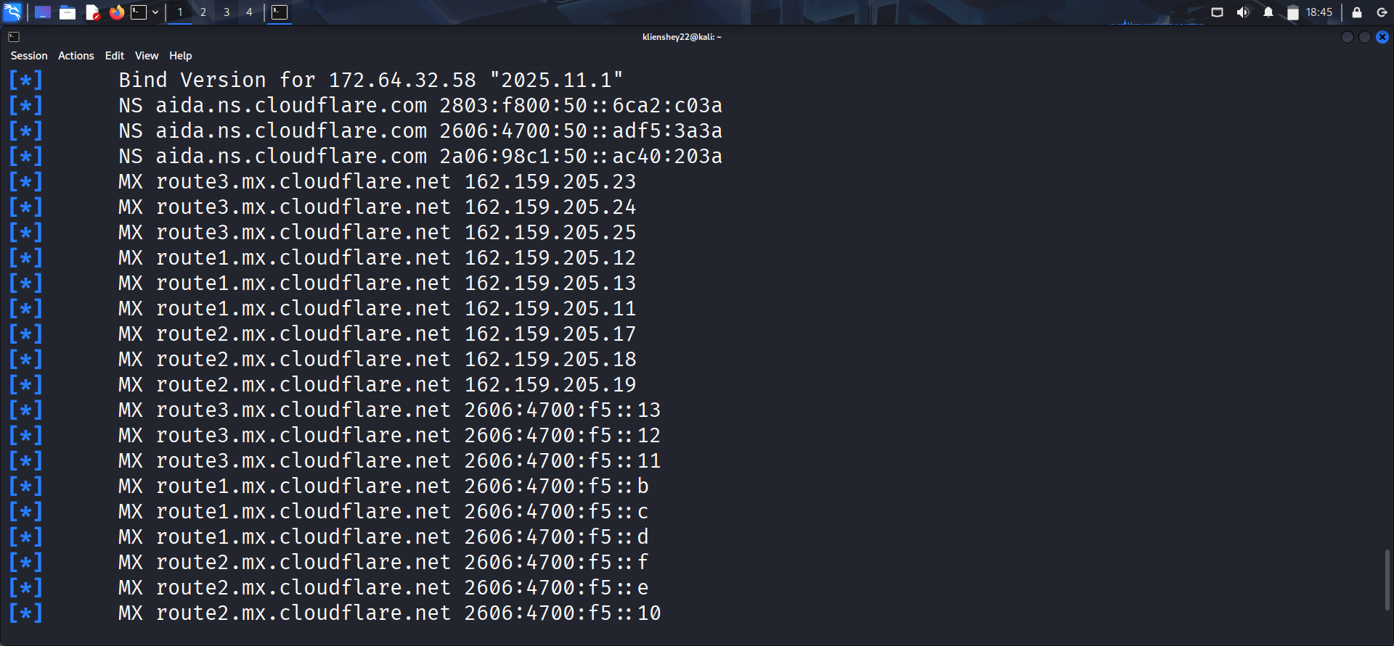
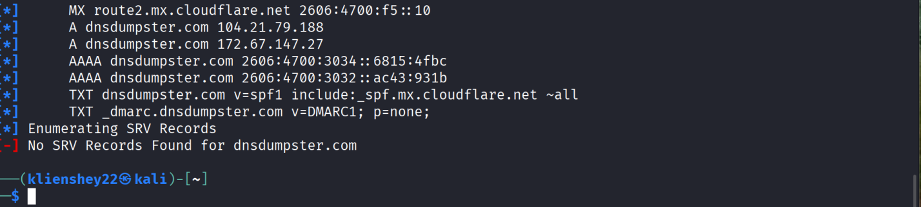

3.5 Web Application Firewall
- Passive approach:
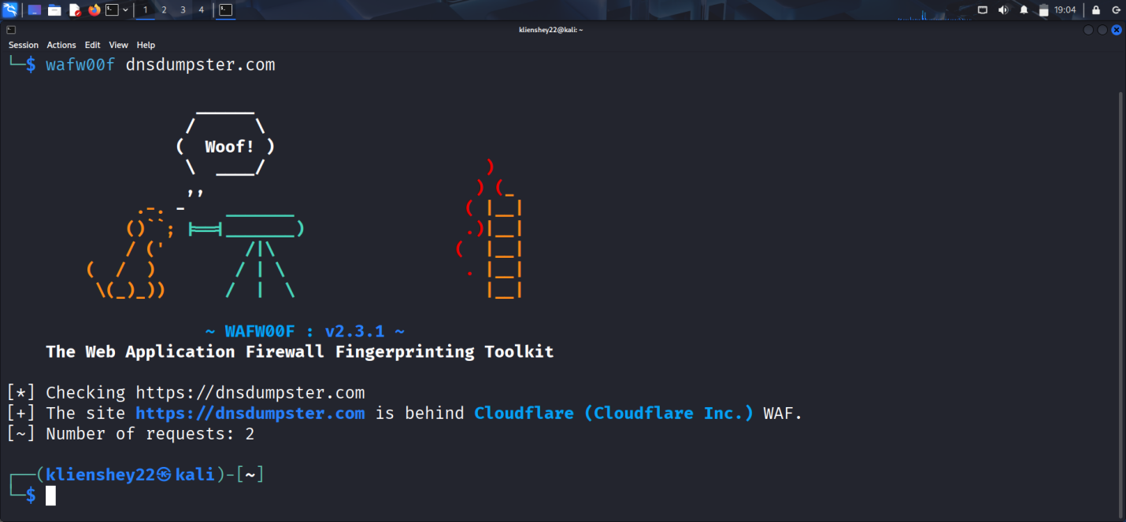

3.6 OSINT: Mentions, Accounts, and Exposure
- SpiderFoot (passive modules):
  - DNS/Hosts: Passive resolution of subdomains from CT/DNS.
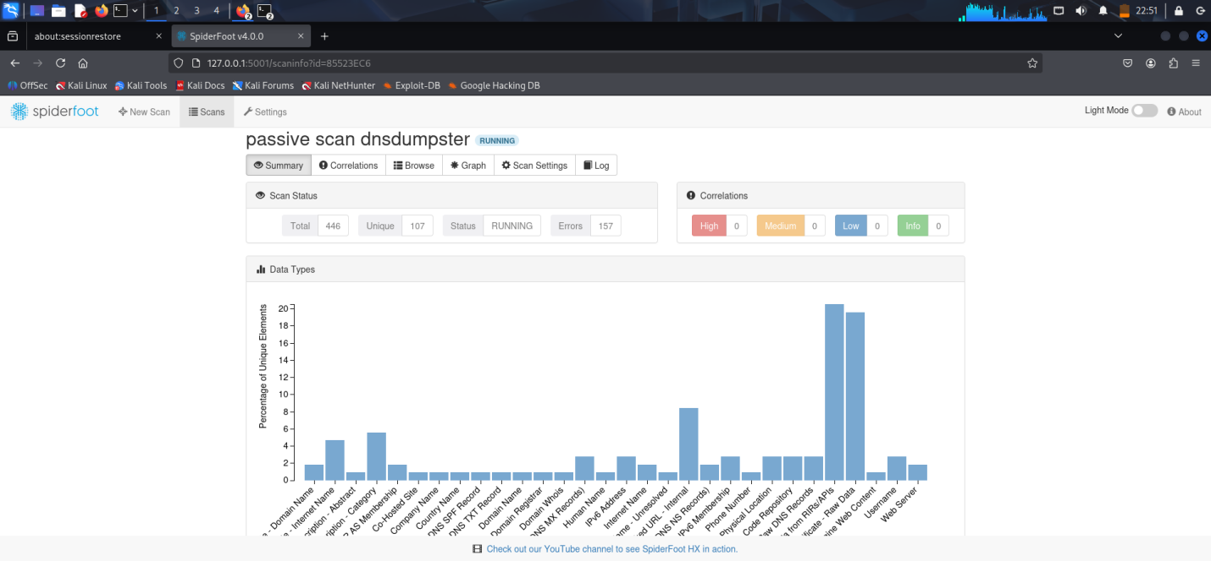
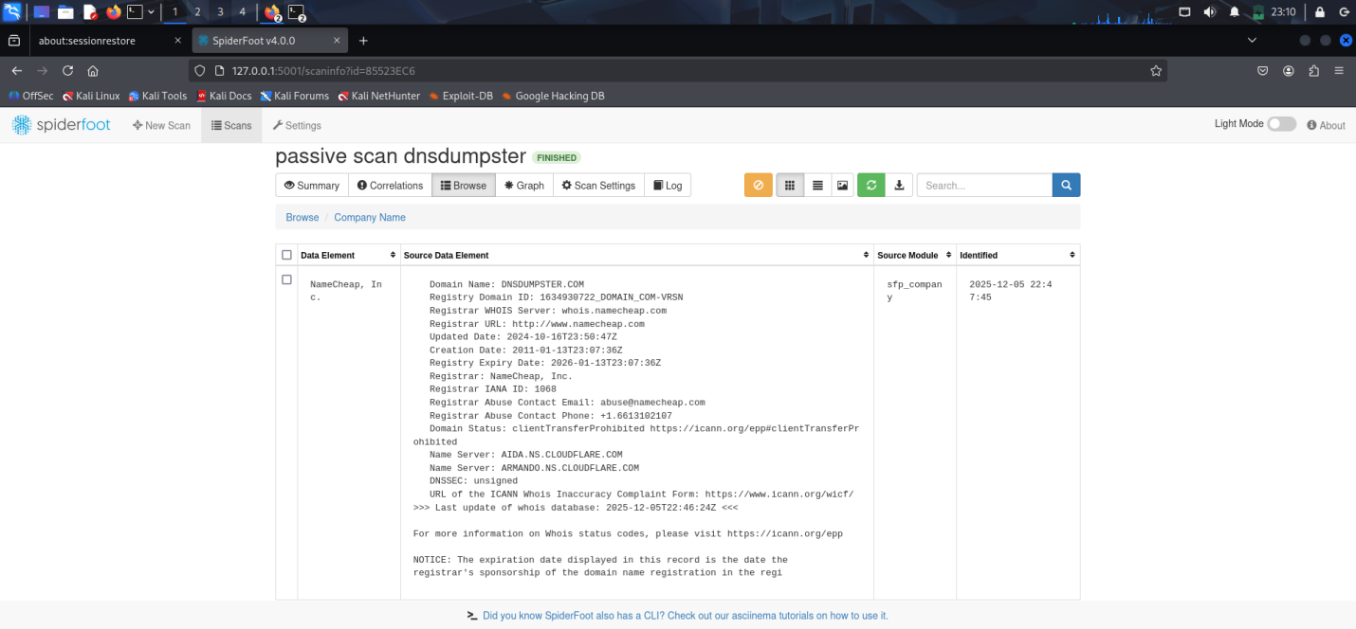

  - Credential exposure: Only passive checks; no repository cloning or brute forcing.
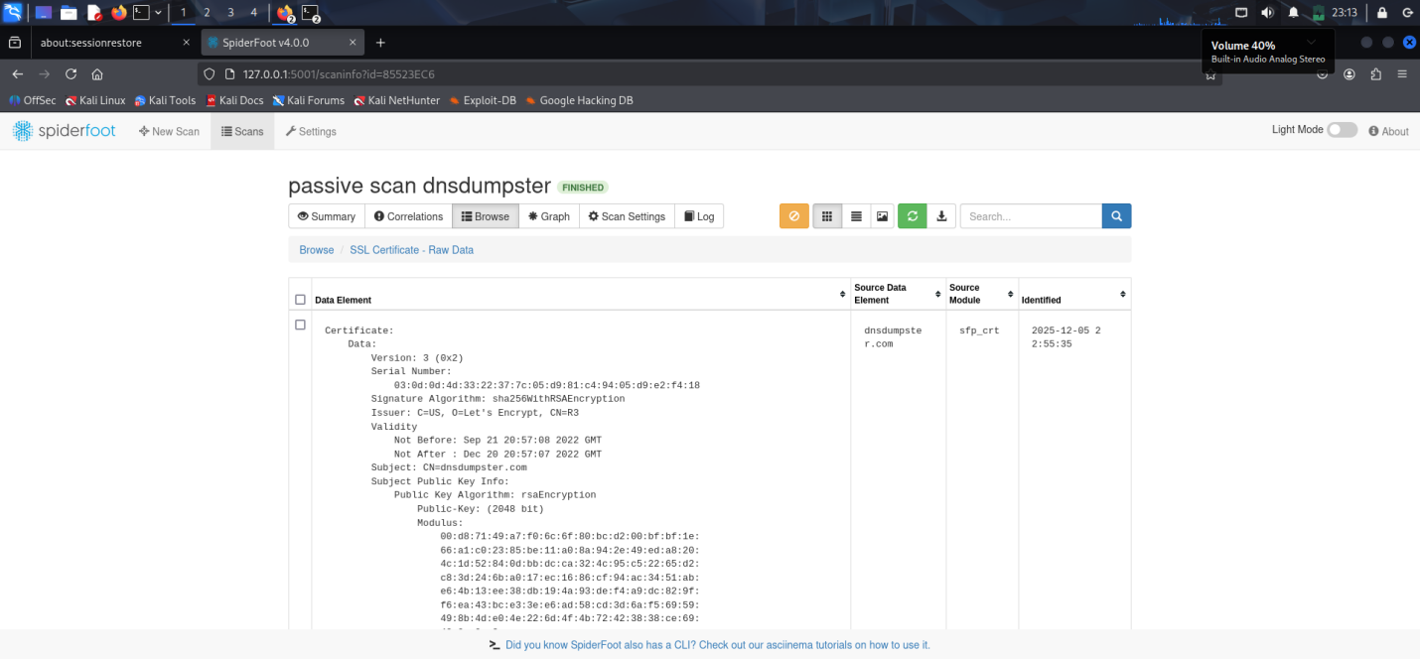

Recommendations (Based on Passive Posture Only)

1. Strengthen HTTP Security Headers
Ensure all modern security headers are correctly configured:

Strict-Transport-Security (HSTS) – enforce HTTPS and prevent downgrade attacks
Content-Security-Policy (CSP) – reduce XSS risk
X-Content-Type-Options – prevent MIME sniffing
Referrer-Policy – limit sensitive data leakage
Permissions-Policy – restrict browser features

2. DNS Hardening & Hygiene
Review TXT records to ensure proper SPF, DKIM, and DMARC alignment
Remove unused or legacy DNS records to reduce attack surface
Ensure CAA records explicitly restrict which Certificate Authorities can issue TLS certificate.

3. Continuous Certificate Transparency (CT) Monitoring
Monitor CT logs for unexpected subdomains or certificates
Helps detect shadow IT, subdomain takeovers, or misconfigurations early

4. Web Application Firewall (WAF) Validation
Periodically re-validate WAF/CDN presence and configuration
Ensure protections cover:
Bot abuse
Layer-7 DDoS
Common web attacks (XSS, SQLi patterns)

5. Public OSINT Footprint Monitoring
Regularly monitor:
Paste sites
Public repositories
Forums and breach databases
Look for leaked credentials, API keys, or internal references

6. Subdomain Inventory Management
Maintain an up-to-date list of all public subdomains
Identify:
Orphaned subdomains
Third-party hosted services
Deprecated assets

7. Adopt Ongoing Passive Recon as a Process
Schedule quarterly passive reconnaissance reviews
Treat OSINT as an early-warning system, not a one-time scan
Helps catch changes in infrastructure, DNS, or exposure over time

8. Documentation & Scope Clarity
Clearly document:
What is in-scope vs out-of-scope
Passive vs active testing boundaries

